**CS385 - Business Proposal Report - Munch**

Gabriel Mendonca & Gabriel Soares

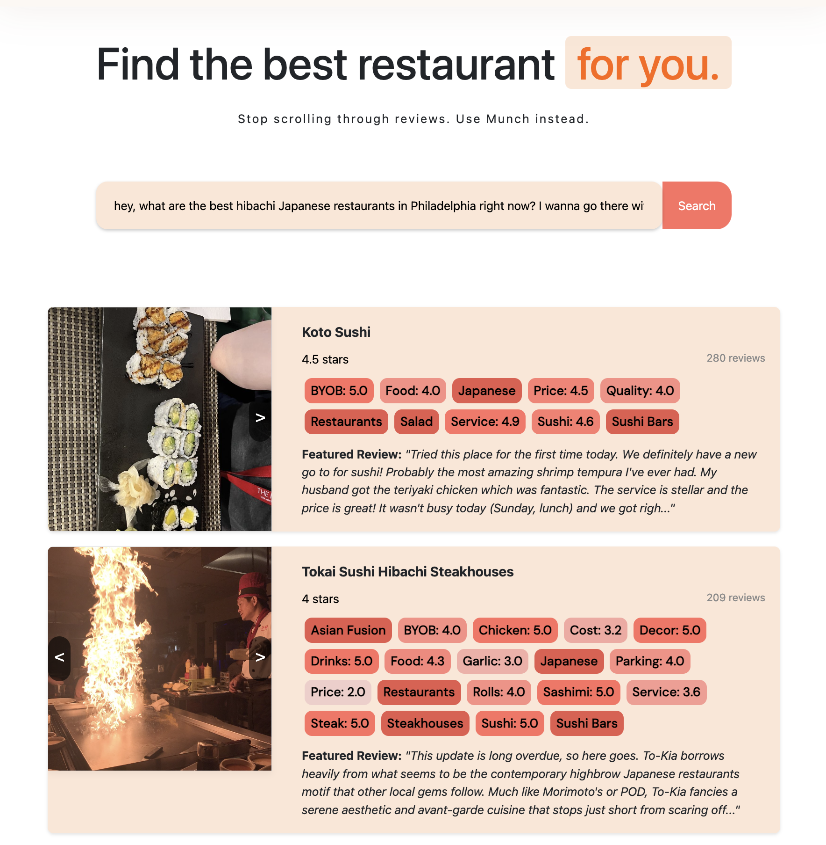

Figure 1: Current App Interface

**1. Introduction:** Our application, Munch, addresses the common challenges faced by users when searching for restaurants online. Traditional keyword-based search systems often fail to capture the nuances of user preferences and can lead to irrelevant or unsatisfactory results. Our AI-powered solution leverages natural language processing and sentiment analysis to provide users with highly personalized and accurate restaurant recommendations.

Our team consists of two Emory University seniors: Gabriel Mendonca, a Computer Science major with skills in Full Stack Development, LLM integration, LlamaIndex Pipeline, and Data Science; and Gabriel Soares, a Business Administration major with expertise in Marketing and Client Acquisition. We have developed an innovative web application that revolutionizes the way people search for restaurants.

**2. Market Analysis:** Our target market primarily consists of tech-savvy urban adults aged 18-49 who are interested in discovering new dining options. This demographic is characterized by their reliance on digital platforms for information and their willingness to explore diverse culinary experiences. The market for online restaurant search and discovery is highly competitive, with established players such as Yelp, Google Maps, and TripAdvisor dominating the space.

However, we have identified significant opportunities in the market. Our user surveys indicate that 70.4% of respondents prefer conversational search over traditional keyword-based search, highlighting the demand for more intuitive and user-friendly interfaces. Additionally, 92.6% of users rated our unique feature scores as "very useful" for selecting a restaurant, demonstrating the value of our AI-driven insights.

The restaurant industry is constantly evolving, with new trends and consumer preferences emerging regularly. The rise of food delivery services and the impact of social media on dining decisions have reshaped the market landscape. Our application is well-positioned to capitalize on these trends by providing users with up-to-date information and personalized recommendations based on real-time data.

**3. Value Proposition:** Munch offers a unique value proposition by leveraging conversational search. Users can input their preferences in natural language, eliminating complex keyword searches and allowing for more intuitive expression of desires. Our application addresses the pain points of information overload and decision fatigue in restaurant search. By analyzing user queries and applying advanced algorithms to our vast dataset of restaurant information, including reviews, ratings, and features, we provide highly relevant and personalized recommendations.

Key differentiators include the use of real-world data and sentiment analysis to generate unique feature scores for each restaurant, such as ambiance, service quality, and specific dish ratings. Compared to existing solutions, our application offers:

**1) Conversational search** for intuitive and user-friendly interactions

**2) Real data fidelity**, minimizing the risk of inaccurate recommendations

**3) Unique feature scores** for informed decision-making based on specific preferences

**4) Highly personalized recommendations** for a more satisfactory user experience

Our AI-powered application saves users time and effort in finding the perfect dining spot while providing valuable insights not readily available on other platforms.

**4. Technical Capabilities:** Our AI-powered restaurant search application is built on a robust technical architecture that combines state-of-the-art AI technologies with efficient data processing and retrieval mechanisms. The core components of our system include:

**1) GPT-3.5 Turbo:** We leverage the power of GPT-3.5 Turbo, a cutting-edge language model, to drive our natural language processing and understanding capabilities. GPT-3.5 Turbo enables our system to interpret user queries, generate personalized recommendations, and provide intelligent responses to user questions about restaurants.

**2) LlamaIndex Library:** We have integrated a LlamaIndex powered pipeline into our system, which serves as the backbone for orchestrating various AI components. The pipeline efficiently indexes and retrieves relevant information from our extensive restaurant database, ensuring fast and accurate search results. GPT-3.5 Turbo is seamlessly integrated into our LlamaIndex agents, allowing for natural language interactions and personalized recommendations.

**3) Sentiment Analysis:** Our AI system employs sophisticated sentiment analysis algorithms to process and analyze user reviews and feedback. By extracting sentiment scores for various aspects of each restaurant, such as ambiance, service quality, and specific dish ratings, we provide users with valuable insights that go beyond basic star ratings. The sentiment analysis enables accurate and nuanced understanding of user opinions.

**4) Data Integration and Processing:** Our application leverages the Yelp Academic Dataset, which provides a rich source of restaurant information, including details such as cuisine type, location, hours of operation, and user reviews. We have further enhanced this dataset by scraping additional data from Yelp, such as restaurant images, to provide users with comprehensive and visually appealing search results. The data is processed and indexed using the LlamaIndex pipeline, ensuring efficient retrieval and analysis.

**5) Cosine Similarity Matching:** To determine the relevance of restaurants to user queries, we employ cosine similarity matching. By embedding user queries and restaurant data into a high-dimensional vector space, we can calculate the cosine similarity between them, enabling us to rank and recommend restaurants based on their relevance to user preferences. Here, OpenAI’ embedding models play a crucial role in generating accurate embeddings and understanding the semantic meaning behind user queries.

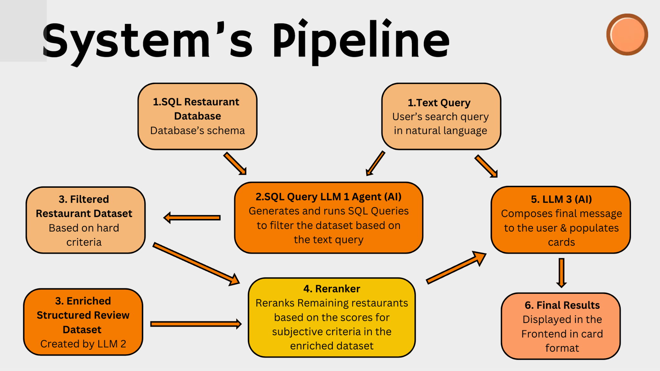

These technical capabilities, powered by GPT-3.5 Turbo and the LlamaIndex pipeline, enable our system to deliver superior performance and outcomes compared to traditional keyword-based search systems. By leveraging advanced natural language processing, sentiment analysis, and data processing techniques, we can provide users with highly personalized and accurate restaurant recommendations, saving them time and effort in finding the perfect dining experience.

**5. Business Model:** Our proposed business model for monetizing Munch focuses on a combination of user subscriptions, AI-enhanced listings for restaurants, and targeted advertising. The key components of our business model are as follows:

**1) User Subscription Plans:**

**Free Tier:** Users can access the core features of our application, including conversational search and personalized recommendations, with a limited number of searches per month.

**Pro Plan:** For a monthly subscription fee, users gain access to additional features, such as advanced filtering options, exclusive restaurant deals, and the ability to ask basic questions about restaurants using GPT-3.5 Turbo. The Pro Plan includes an increased number of searches compared to the Free Tier.

**Premier Plan:** At a higher monthly subscription fee, users receive premium benefits, such as unlimited searches, priority customer support, early access to new features, and the ability to conduct in-depth restaurant analysis using GPT-4 Turbo. The Premier Plan allows users to ask complex questions about restaurants, and the AI system will provide detailed insights by analyzing the restaurant's unique feature scores, citing relevant reviews, and retrieving menu information to offer a comprehensive assessment of the restaurant's suitability for specific preferences.

**2) AI-Enhanced Listings for Restaurants:**

**Basic Insights:** Restaurants can access complimentary basic insights derived from our AI analysis, including sentiment scores and user preferences.

**Detailed Reports:** For a monthly fee, restaurants can unlock detailed AI-generated reports that provide actionable insights for improving their offerings and customer satisfaction.

**Featured Listings:** Restaurants can pay to have their listings prominently featured in search results, increasing their visibility to potential customers.

**3) Advertising and Partnerships:**

**Targeted Advertising:** We will offer targeted advertising opportunities to restaurants and related businesses, allowing them to reach our user base of food enthusiasts. Advertisers will be charged on a pay-per-click basis.

**Reservation Fees:** By partnering with reservation platforms, we can generate revenue by charging a small fee per reservation made through our application.

**Data Licensing:** We can explore commercial data licensing agreements with major restaurant search platforms, providing them with access to our unique AI-generated insights and user data.

By combining user subscriptions, AI-enhanced listings for restaurants, and targeted advertising, we create a diversified revenue stream for long-term sustainability and growth, with revenue goals set based on projected user base growth and adoption of tiered subscription plans.

**6. Commercialization Plan:** Our plan for scaling and commercializing Munch involves a phased approach:

1. **Beta Launch and User Acquisition:** Launch beta version in selected cities like Philadelphia and Atlanta. Focus on targeted digital marketing campaigns on TikTok and Instagram, leveraging food influencers. Gather user feedback to refine algorithms and optimize marketing efforts.
2. **Expansion and Scaling:** Gradually expand to other major urban areas with vibrant food scenes and tech-savvy populations. Continuously enhance our AI system, incorporating user feedback and advancing algorithms. Design cloud infrastructure to scale seamlessly and handle growing user demand.
3. **Partnership Development:** Seek partnerships with restaurants, food bloggers, and local food communities to expand our database. Collaborate with reservation platforms and food delivery services for additional revenue streams. Explore data licensing agreements with major restaurant search platforms.
4. **Regulatory and Compliance:** Prioritize data privacy and security, complying with regulations like GDPR and CCPA. Adhere to the current legality of data scraping, only utilizing publicly available data. Work with legal experts to navigate regulatory challenges.

Our unique value proposition, powered by GPT-3.5 Turbo and GPT-4 Turbo, coupled with our focus on user acquisition and partnership development, positions us well to capture a significant share of the online restaurant search market.

**7. Conclusion:** In summary, Munch revolutionizes the way users discover and explore dining options. By leveraging advanced technologies such as GPT-3.5 Turbo, LlamaIndex pipeline, and sentiment analysis, we provide users with highly personalized and accurate restaurant recommendations based on their preferences expressed in natural language.

Our unique value proposition addresses the pain points of traditional keyword-based search systems, offering intuitive conversational search, real data fidelity, and unique feature scores for informed decision-making. With a target market of tech-savvy urban adults and a competitive landscape ripe for disruption, our application is well-positioned to capture a significant share of the online restaurant search market.

Our phased commercialization plan, focusing on user acquisition, expansion, partnership development, and regulatory compliance, ensures a solid foundation for long-term growth and success. By combining user subscriptions, AI-enhanced listings for restaurants, and targeted advertising, we create a diversified and sustainable revenue stream.

The potential impact of our AI-powered restaurant search application extends beyond user convenience. By providing restaurants with valuable AI-generated insights and actionable recommendations, we empower them to enhance their offerings, improve customer satisfaction, and ultimately, thrive in a competitive market. Our application has the potential to become the go-to platform for restaurant discovery, transforming the way people explore and experience dining options in their cities.